Software Architecture and Design Specification
Project: Online Bookstore
Version: 1.0
Authors: Group 2
Date: 05-10-2026
Status: Draft for Submission
A multi-seller e-commerce platform for buying and selling new and second-hand books.
PES University, Bengaluru | UE24CS341A - Software Engineering | Semester V

Revision History
Version | Date | Author | Change Summary
0.1 | 02 Sep 2026 | Group 2 | Initial SAD draft aligned with the assigned Online Bookstore project.
0.5 | 05 Oct 2026 | Group 2 | Architecture, component design, security architecture, API design and sequence flows prepared from SRS v1.0.
1.0 | 05 Oct 2026 | Group 2 | SAD baseline prepared for Mini-Project Deliverables Part-1.

Approvals
Role | Name | Signature / Date
Project Team | Group 2 | ________________ / 05-10-2026
Faculty / Reviewer | ________________ | ________________

Document Overview
This document describes the software architecture and detailed design of the Online Bookstore. It translates the approved SRS into architectural components, interfaces, security controls, design flows and traceability. The architecture is based on a React client, Node.js/Express service layer and MongoDB data store, with Redis, a payment gateway, SMTP e-mail and cloud object storage as supporting interfaces.

Contents
1. Introduction
2. Document Overview
3. Architecture
4. Design
5. Appendices

1. Introduction

1.1 Purpose
This Software Architecture and Design Specification (SAD) defines the architecture and design of the Online Bookstore described in the approved SRS. It identifies the major software components, their responsibilities, interactions, technology choices, security controls, design interfaces and representative execution flows.

1.2 Scope
The SAD covers version 1.0 of the Online Bookstore: account and access management; catalogue, search and reviews; cart, wishlist, checkout, payment and order tracking; seller listing and fulfilment operations; administrator moderation and reporting; and the supporting persistence, caching, notification and external-service interfaces.

1.3 Audience
Developers implementing the React, Node.js/Express and MongoDB solution.
QA/test engineers deriving integration and system tests from the design.
Project faculty and reviewers evaluating architecture and requirement coverage.
Security reviewers checking authentication, authorization, payment and audit controls.
Maintainers who need to understand component responsibilities and dependencies.

1.4 Definitions
Term | Meaning
MERN | MongoDB, Express.js, React and Node.js technology stack.
JWT | JSON Web Token used for authenticated access.
RBAC | Role-Based Access Control.
OTP | Six-digit One-Time Password used for e-mail verification.
Listing | One seller's offer of one book title, with its own condition, price and stock.
ISBN-13 | Thirteen-digit identifier used to identify a catalogue title.
NFR | Non-functional requirement.
RTM | Requirement Traceability Matrix.

1.5 References
Software Requirements Specification - Online Bookstore, Group 2, Version 1.0 approved, 10 September 2026.
IEEE Std 830-1998, Recommended Practice for Software Requirements Specifications.
Project Guidelines for UE24CS341A, Semester V 2026.
MongoDB documentation for text indexes and aggregation pipeline.
OWASP Top 10 (2021).

2. Document Overview

2.1 How to Use This Document
Section 3 should be used to understand the system architecture, component responsibilities, architecture pattern, technology stack, risks, requirement traceability and security architecture. Section 4 should be used for implementation-level design, representative API contracts, sequence flows, error handling and user-experience decisions. The appendices provide traceability, glossary material and design assumptions.

2.2 Related Documents
Online Bookstore SRS Version 1.0.
Requirement Traceability Matrix in Appendix C of the SRS.
Test Plan / Software Test Plan for the Online Bookstore.
Appendix B field layouts and report requirements workbook referenced by the SRS.

3. Architecture

3.1 Goals & Constraints
The architecture is designed to satisfy the approved requirements without unnecessary complexity. Primary goals are secure authentication and authorization, reliable order and stock processing, responsive catalogue search, maintainable modular services, testability through injectable interfaces, and reuse through a shared React component library.
Category | Architecture goal / constraint
Performance | Catalogue search within 2 seconds at the 95th percentile under 10,000 listings and 200 concurrent users; catalogue/detail pages within 3 seconds.
Availability | At least 99% availability during the evaluation window, measured through a health-check monitor.
Security | TLS 1.2+, bcrypt password hashes, short-lived access tokens, RBAC, server-side validation, no card-data storage and append-only audit logging.
Data integrity | Atomic stock decrement at payment confirmation; no hard deletion of order/payment/shipment history.
Technology | MERN stack is fixed by the project brief; MongoDB Atlas and Redis are used as specified by the SRS.
Delivery | Four part-time developers must implement, test and demonstrate the product within one semester.
Operations | Third-party services remain within free tiers; source is managed in one protected GitHub repository with CI gates.

3.2 Stakeholders & Concerns
Stakeholder | Primary concerns
Buyer | Fast discovery, correct pricing/stock, secure checkout, order visibility and usable responsive UI.
Seller | Simple listing/inventory management, fulfilment workflow, low-stock alerts and accurate settlement reports.
Administrator | Moderation, auditability, user management, platform analytics and exports.
Developers | Clear module boundaries, testability, maintainability and CI quality gates.
Faculty / Evaluators | Traceability to SRS requirements, demonstrable functionality and measurable quality attributes.
Security / Compliance reviewers | TLS, password protection, RBAC, payment isolation, audit logs and OWASP-aligned validation.

3.3 Component (UML) Diagram
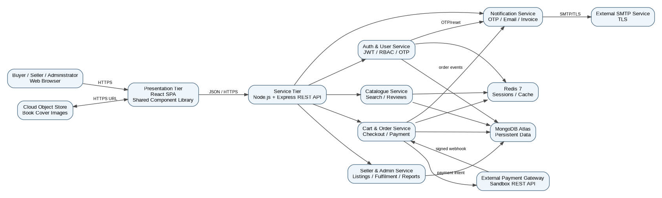
Figure 1. Component architecture - Online Bookstore
The component view implements the three-tier perspective stated in the SRS. The React presentation tier communicates with the Node.js/Express REST service tier over HTTPS/JSON. The service tier is split by responsibility into authentication/user, catalogue/search/review, cart/order/payment, seller/administrator and notification services. MongoDB is the primary persistent store; Redis provides session storage and query caching; payment and SMTP remain outside the application trust boundary.

3.4 Component Descriptions
Component | Responsibilities | Main requirements supported
React Presentation Tier | Buyer, seller and administrator screens; shared components; responsive layout; form validation feedback; authenticated navigation. | FR-01 to FR-24; NFR-04, NFR-07
Auth & User Service | Registration, OTP verification, login/logout, JWT/refresh tokens, password reset, profile/address management and RBAC. | FR-01 to FR-06; NFR-03, NFR-08
Catalogue Service | Catalogue paging, text search, filtering/sorting, book detail, reviews and related-title selection. | FR-07 to FR-12; NFR-01
Cart & Order Service | Cart/wishlist, checkout validation, order lifecycle, payment coordination, invoice triggering and cancellation/return. | FR-13 to FR-18; NFR-05
Seller & Admin Service | Listing/inventory management, low-stock handling, fulfilment, seller dashboard, moderation and platform reports. | FR-19 to FR-24; NFR-02, NFR-06
Notification Service | OTP, order confirmation, invoice and low-stock e-mail delivery; queue/retry handling. | FR-02, FR-04, FR-17, FR-20, FR-21
MongoDB Atlas | Persistent collections for users, addresses, books, listings, carts, orders, payments, shipments, reviews and notifications. | Persistent system data
Redis | Session storage and query caching for repeated filter/search combinations. | NFR-01 and session support
Payment Gateway | Sandbox authorization/capture; application receives payment status through a signed callback. | FR-16; payment security
SMTP Service | TLS e-mail delivery for OTPs, confirmations, invoices and alerts. | FR-02, FR-04, FR-17, FR-20, FR-21
Cloud Object Store | Storage/retrieval of book cover images. | External interface 3.2

3.5 Chosen Architecture Pattern and Rationale
The system uses a three-tier layered architecture with modular services inside the application/service tier. This is consistent with the SRS product perspective: React SPA as the client, Node.js/Express as the REST service layer, and MongoDB as the data store, with Redis and external services supporting the application. The pattern separates presentation, business/service logic and persistence concerns, while the internal service boundaries keep authentication, catalogue, ordering and seller administration independently testable.
Presentation layer: React SPA and shared component library.
Service layer: Express REST API and responsibility-oriented service modules.
Persistence/integration layer: MongoDB, Redis, payment gateway, SMTP and object storage.
External systems are isolated behind interfaces so payment and e-mail can be stubbed in tests.
A microservices deployment is not required for the current semester-scale system. Keeping the modules within one service deployment reduces operational overhead while preserving clear logical boundaries and future extraction points.

3.6 Technology Stack & Data Stores
Layer / Area | Technology | Purpose
Client | React | Single-page responsive application and shared UI components.
Server | Node.js 20 LTS + Express.js | REST API and service orchestration.
Database | MongoDB 7 / MongoDB Atlas | Primary persistent document store.
ODM | Mongoose 8 | Application-side document modelling and database access.
Cache / Session | Redis 7 | Session storage and five-minute query/filter cache.
Authentication | JWT + bcrypt | Access/refresh token model and password hashing.
Payment | Sandbox REST payment gateway | Payment intent, authorization/capture and callback.
Notification | SMTP over TLS | OTP, order confirmation, invoice and alert e-mail.
Images | Cloud object store | Book cover image storage.
API contract | OpenAPI document | Authoritative REST API contract maintained in repository.
CI / Quality | ESLint + unit tests | Zero ESLint errors and minimum 70% service-module unit-test coverage.

3.7 Risks & Mitigations
Risk | Impact | Mitigation
Payment gateway unavailable | Checkout cannot complete. | Leave order in PLACED state, do not decrement stock, display retry path and rely on sandbox availability assumption.
SMTP unavailable | OTP/notification delivery delayed. | Queue notification and retry up to three times with exponential backoff; expose resend for OTP.
Redis unavailable | Performance degradation and session/cache disruption. | Use read-through caching and database fallback for session storage as stated in SRS.
Concurrent purchase of last stock | Overselling and data inconsistency. | Atomic stock decrement at payment confirmation; verify with concurrent system test.
Unauthorized route/object access | Privacy or privilege violation. | Server-side RBAC and object-level ownership checks on every protected read.
Database/service failure | Availability loss. | Managed database, health checks, daily automated backup and restore rehearsal before demonstration.
Third-party free-tier limits | Resource exhaustion. | Monitor storage/e-mail/container usage and keep external integrations within free-tier constraints.

3.8 Traceability to Requirements
The architecture mapping below summarizes the SRS traceability approach. The complete SRS RTM maps FR-01 to FR-24 and NFR-01 to NFR-08 to architecture, design, code and test artefacts.
Requirement | Architecture reference | Design responsibility
FR-01–FR-06 | Auth & User Service | Registration, OTP, JWT, profile/address and RBAC
FR-07–FR-12 | Catalogue Service | Paging, search, filters, detail, reviews and related titles
FR-13–FR-18 | Cart & Order Service | Cart, wishlist, checkout, payment, invoice and order lifecycle
FR-19–FR-24 | Seller & Admin Service | Listings, inventory, fulfilment, settlement, moderation and analytics
NFR-01 | Catalogue + Redis | Indexed search and cache under reference load
NFR-02 | Deployment + monitoring | Health endpoint and uptime monitoring
NFR-03 | Auth + API + payment integration | TLS, bcrypt, token expiry and payment isolation
NFR-04 | React Presentation Tier | Four-screen checkout, 360px usability and WCAG AA
NFR-05 | Cart & Order Service + MongoDB | Atomic stock decrement
NFR-06 | All service modules + CI | ESLint and unit-test coverage gate
NFR-07 | React Presentation Tier | Cross-browser compatibility
NFR-08 | Auth/Order/Seller/Admin + Audit Log | Append-only administrative/payment audit events

3.9 Security Architecture
Security controls are layered across the client, service tier, data tier and external integrations. The payment gateway remains outside the application boundary so that card data does not enter or get stored by the bookstore.
Threat / Concern | Control | Design location
Spoofing / credential theft | bcrypt cost 12, e-mail OTP verification, short-lived access tokens and refresh-token rotation. | Auth & User Service
Broken authorization / privilege escalation | Server-side RBAC on every protected route and object-level ownership checks. | Express middleware / services
Tampering | HTTPS/TLS, server-side validation/sanitisation, signed payment webhook verification and idempotent callback handling. | API/service layer
Information disclosure | No card data stored; sensitive fields excluded from logs; HTTPS; controlled object ownership. | API, payment integration, data access
Injection / XSS | Server-side validation and sanitisation; OWASP Top 10 review. | All API inputs
Denial of Service / abuse | Failed-login rate limiting and OTP request cap; health monitoring. | Auth service / deployment
Repudiation | Append-only audit log for every administrative action and payment event. | Audit logging
Data loss | Daily automated backups retained for seven days and restore rehearsal. | MongoDB Atlas / operations

4. Design

4.1 Design Overview
The detailed design follows the architectural boundaries in Section 3. Each service exposes focused operations through the Express REST layer. Persistent data is stored in the eleven collections defined by the SRS. Service-layer validation is used for relationships because MongoDB does not enforce relational foreign keys. Order lines store the unit price at purchase time so later seller price changes cannot modify historical order values.

4.1.1 Key Data and Service Responsibilities
Design area | Decision
Identity | USER is a single collection with a role attribute; a person may be both buyer and seller, while administrator is separate.
Catalogue | BOOK identifies a title by ISBN-13; LISTING connects a title to a seller and carries condition, price and stock.
Orders | ORDER stores lifecycle state; ORDER_ITEM freezes unit price at purchase time and references the listing.
Payment | PAYMENT records attempts against an order; card details remain exclusively with the payment gateway.
Notification | NOTIFICATION records outbound messages and delivery outcome for audit/retry handling.
Caching | Redis caches repeated filter combinations with a five-minute TTL and supports session storage.
Reporting | Aggregation queries generate seller and administrator reports; exports are CSV/PDF as specified.

4.2 UML Sequence Diagrams
Two representative sequences are included below. They cover account activation and the critical checkout/payment flow specified in the SRS.

4.2.1 Sequence Diagram - Registration and OTP Verification
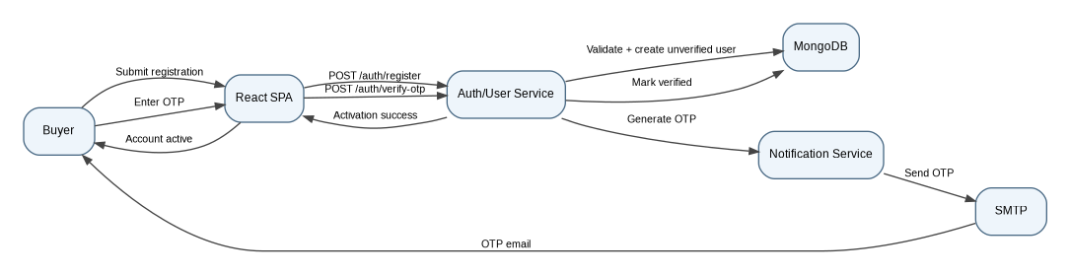
Figure 2. Registration, OTP generation, e-mail delivery and verification
The registration flow creates an unverified user, generates a six-digit OTP and sends it through the notification/SMTP path. Verification activates the account. The SRS further constrains OTP validity to ten minutes, limits resend frequency, and blocks unverified accounts from signing in.

4.2.2 Sequence Diagram - Checkout and Payment Confirmation
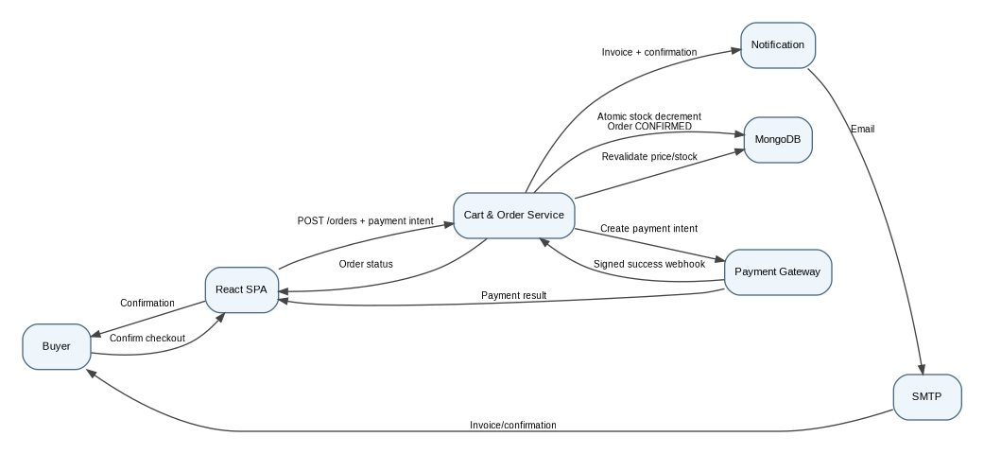
Figure 3. Checkout, payment gateway callback, stock update and notification
The checkout flow revalidates current price and stock before creating a payment intent. The application trusts only a signature-verified gateway callback. On success, stock is decremented atomically and the order moves to CONFIRMED; on failure the order remains PLACED and stock is not decremented. The callback is idempotent so repeated callbacks do not confirm an order twice.

4.3 API Design
The SRS specifies a REST API over HTTPS with JSON requests/responses and bearer JWT authentication. The following are representative design interfaces derived from the SRS requirements; the repository OpenAPI document remains the authoritative implementation contract.
Component / Endpoint | Method | Request / Inputs | Response / Outputs | Key errors / controls
Auth /api/auth/register | POST | name, email, phone, password, role | Unverified user; OTP dispatch status | 400 validation/duplicate email
Auth /api/auth/verify-otp | POST | email, otp | Verification success/session | 400 invalid/expired OTP; 429 request limit
Catalogue /api/books/search | GET | q, category, price, condition, language, rating, sort, page | Paged results | 400 invalid filter; indexed search
Cart /api/cart/items | POST | listingId, quantity | Updated cart line/totals | 400 invalid quantity/stock; ownership
Order /api/orders | POST | cart, addressId, couponCode | PLACED order + payment intent ref | 400 revalidation failure
Payment /api/payments/webhook | POST | Signed gateway callback | Idempotent acknowledgement | 401 invalid signature; duplicates ignored
Seller /api/seller/listings | POST | isbn13, condition, price, mrp, stock | Created/updated listing | 400 price > MRP; RBAC
Admin /api/admin/reports | GET | month, report type, export format | Report data or CSV/PDF | 403 non-admin; aggregation handling

4.3.1 API Design Rules
All application API traffic uses HTTPS with TLS 1.2 or higher; plain HTTP is redirected to HTTPS.
Authenticated requests carry a bearer JWT in the Authorization header.
Errors return an HTTP status, stable machine-readable error code and human-readable message.
The payment webhook verifies its signature before trusting the payload and is idempotent.
CORS accepts only the deployed client origin.
Sensitive information such as passwords, tokens and card details is never written to application logs.

4.4 Error Handling, Logging & Monitoring
Area | Design
Validation | Validate all user input server-side; return field-level validation messages in the client.
Authentication | Return 401 for missing/invalid authentication and 403 for authenticated users without required role/ownership.
Payment | Gateway failure leaves order PLACED, preserves stock and permits the defined retry count.
Notification | Queue failed e-mail and retry up to three times; final failure is recorded.
Database | Use compensating records rather than hard deletion for order/payment/shipment history.
Logging | Do not log passwords, card data or other sensitive authentication material.
Audit | Record every administrative action and payment event with actor, action, target and timestamp in an append-only audit log.
Monitoring | Monitor health/uptime, search latency, payment failure rate, notification failures and critical service errors.

4.5 UX Design
The React client uses a shared component library for buyer, seller and administrator surfaces. The persistent header provides search, cart and account access on buyer-facing screens. The UI is responsive down to a 360 px viewport, uses inline field-level errors, requires confirmation for destructive actions, supports keyboard navigation and targets WCAG 2.1 AA contrast. Checkout is constrained to at most four screens from cart to confirmation.
Buyer surfaces: Home/Catalogue, Search Results, Book Detail, Cart, Checkout, Order Confirmation, Order History/Tracking.
Seller surfaces: Listing Form, Inventory, Seller Dashboard and fulfilment views.
Administrator surfaces: Moderation Queue and Analytics/Reports.
Failed payments explain the failure and expose a retry path instead of showing only a status code.

4.6 Open Issues & Next Steps
Complete and freeze the repository OpenAPI contract for all production routes.
Implement component interfaces with injected payment and SMTP adapters so external services can be stubbed in tests.
Generate final UML diagrams in the team's chosen modelling tool if editable diagram source files are required.
Complete the security review against OWASP Top 10 before demonstration.
Run the 200-concurrent-user search test and verify the 2-second 95th-percentile target.
Run the concurrent last-copy purchase test to demonstrate atomic stock handling.
Complete cross-browser regression and accessibility walkthrough.
Rehearse the database restore once before the final demonstration.

5. Appendices

5.1 Glossary
Term | Meaning
BOOK | Catalogue title identified independently of a seller.
LISTING | Seller-specific offer of a title, carrying condition, price and stock.
ORDER | Purchase record containing the order summary and lifecycle state.
ORDER_ITEM | Order line that freezes the unit price at purchase time.
RBAC | Role-Based Access Control used to restrict protected routes.
JWT | JSON Web Token used for authenticated access.
OTP | Six-digit one-time password used for e-mail verification.
NFR | Non-functional requirement such as performance, security or usability.
RTM | Requirement Traceability Matrix connecting requirements to architecture, code and tests.

5.2 Requirement-to-Design Traceability Extract
Requirement range | Primary design reference | System test coverage
FR-01–FR-06 | Auth & User Service | STC-01 to STC-03
FR-07–FR-12 | Catalogue Service | STC-04 to STC-06
FR-13–FR-18 | Cart & Order Service | STC-07 to STC-09
FR-19–FR-24 | Seller & Admin Service | STC-10 to STC-12
NFR-01–NFR-02 | Catalogue/Redis + monitoring | STC-13
NFR-03–NFR-04 | Security + React UX | STC-14
NFR-05–NFR-06 | Order persistence + CI | STC-15
NFR-07–NFR-08 | React compatibility + Audit Log | STC-16

The SRS traceability appendix defines sixteen system test cases (STC-01 to STC-16) covering the functional and non-functional requirements. The complete RTM remains the authoritative mapping for code-file and individual test-case references.

5.3 Architecture Decisions
Decision | Choice | Rationale
AD-01 | Three-tier layered architecture | Matches the SRS product perspective and separates presentation, service and persistence responsibilities.
AD-02 | Modular service boundaries inside Express | Keeps the semester-scale deployment simple while isolating authentication, catalogue, order and seller/admin concerns.
AD-03 | MongoDB Atlas as primary store | Matches the fixed MERN stack and the SRS document-oriented collection design.
AD-04 | Redis for sessions/cache | Supports NFR-01 performance and the SRS session/cache design.
AD-05 | External payment gateway | Prevents card data from entering the application and keeps payment handling outside the application trust boundary.
AD-06 | SMTP adapter with retry queue | Provides OTP and transaction notifications while handling temporary delivery failures.
AD-07 | Shared React component library | Supports reusability and consistent buyer/seller/admin UI surfaces.

5.4 Tools
Microsoft Word / DOCX for document preparation.
draw.io or PlantUML for editable UML artefacts, if required by the course.
OpenAPI/Swagger for REST contract documentation.
GitHub and CI for version control and quality gates.

